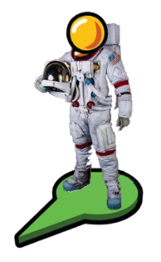

**Explore the Apollo 11 Mission**

**With Google Maps Moon, The NASA Video and Image Libraries, and Google Arts & Culture**

**If you can’t click the links below, visit this site:** <https://goo.gl/CXhDxu>

**Liftoff**

On the morning of July 16, 1969 astronauts [Neil A. Armstrong, Michael Collins and Edwin "Buzz" Aldrin](https://images-assets.nasa.gov/image/8903695/8903695~orig.jpg) sat inside the command module of the Apollo 11 Saturn V rocket. At 9:30 AM, mission control started the final countdown sequence for lift-off. The astronauts inside reported all systems a “go.” At 9 seconds before lift-off, the rocket’s ignition system [was started](https://www.google.com/culturalinstitute/beta/asset/-/7QGK2FYBoDm0mw). 3…2…1…0… [liftoff.](https://www.google.com/culturalinstitute/beta/asset/apollo-xi-launch/YgHQWB-Urjig-A) The Apollo 11 mission began its 8-day journey to put the first man on the Moon.

The Saturn V rocket pushed the astronauts through Earth’s atmosphere and into space with three different rocket engines, called stages. The first two stages thrust them into space, while the third helped the Apollo spacecraft [orbit Earth](http://www.hq.nasa.gov/alsj/a11/AS11-36-5295HR.jpg) and slingshot towards the Moon.

The Apollo 11 spacecraft had [three parts](https://www.google.com/culturalinstitute/beta/asset/-/wwGL8AiDj2u0hA?ms=%7B%22x%22%3A0.5%2C%22y%22%3A0.5%2C%22z%22%3A9.235197028971449%2C%22size%22%3A%7B%22width%22%3A2.182987684729064%2C%22height%22%3A1.2375%7D%7D): the [Command and Service Modules](https://www.google.com/culturalinstitute/beta/asset/apollo-command-service-module-csm/QwGBRJKfoG_1IQ) (named Columbia) and the [Lunar Landing Module](https://www.google.com/culturalinstitute/beta/streetview/LwFYk-4c_yIv1Q?sv_lng=-98.67010412020431&sv_lat=35.54491068667382&sv_h=322.27260752552064&sv_p=-4.738549092513352&sv_pid=j3LvWbtU6b4msP8pjQLn5Q&sv_z=0.9894031133912771) (named Eagle). The astronauts rode in the conical shaped [command module](http://3d.si.edu/apollo11cm/) during launch, travel, and reentry. The large cylinder behind the command module is the service module. The service module supplied the craft with oxygen, water, electrical power, communication, and propulsion.

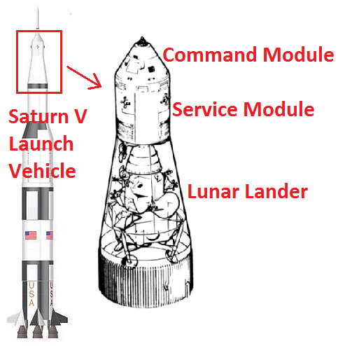

After 1 ½ orbits around earth the third engine was used up and separated from the Columbia spacecraft. Immediately after separation, the astronauts turned the command module around and attached the lunar module to the front of the command module. All three parts flew to the moon connected together as one spacecraft.

**Lunar Descent**

Once the spacecraft reached the Moon the astronauts guided it into lunar orbit. They used this time to [photograph the lunar surface](http://www.hq.nasa.gov/alsj/a11/AS11-44-6549HR.jpg) and plan their descent. After 30 orbits around the moon Armstrong and Aldrin boarded the Eagle Lunar Lander, [separated from the command module](http://www.hq.nasa.gov/alsj/a11/AS11-37-5444HR.jpg), and [descended to the surface](https://images-assets.nasa.gov/image/as11-44-6642/as11-44-6642~orig.jpg). Astronaut Collins remained alone in the command and service module, orbiting above the moon for the duration of surface operations. Throughout the descent Aldrin called out navigation data to Armstrong, who was piloting the lander. A few moments before the landing, a light informed Aldrin that at least one of the 67-inch probes hanging from Eagle's footpads had touched the surface, and he called out: "Contact light!" Three seconds later, Eagle landed and Armstrong said, "Houston, Tranquility Base here. The Eagle has landed."

**Surface Operations**

The astronauts spent two hours after touchdown [looking out their windows](http://www.hq.nasa.gov/alsj/a11/AS11-39-5742HR.jpg) and planning the surface mission. After all checks were complete a hatch on the side of the lander opened and Armstrong emerged onto a ladder. While still on the ladder, Armstrong [uncovered a plaque](http://www.hq.nasa.gov/alsj/a11/AS11-40-5899.jpg) mounted on the lunar module bearing drawings of Earth and an message for any future visitors to read. Armstrong stepped off Eagle's [ladder and declared](https://www.google.com/culturalinstitute/beta/asset/mission-apollo-saturn-11-neil-armstrong-s-boot-and-foot-print-on-the-moon-after-the-first-step-on-the-lunar-surface/IwGi43yNIU8KeQ), "That's one small step for man, one giant leap for mankind."

Twelve minutes after Neil Armstrong set foot on the moon he was [Link Example 1](http://www.hq.nasa.gov/alsj/a11/as11-5864-69HR.jpg). The two astronauts spent over 2 hours on the surface [collecting soil and rock samples](http://www.hq.nasa.gov/alsj/a11/AS11-40-5963HR.jpg), [erecting an American flag](https://www.google.com/culturalinstitute/beta/asset/apollo-11-moonwalk/3QHUzc0Wfl2ycw), [conducting a solar wind experiment,](http://www.hq.nasa.gov/alsj/a11/AS11-40-5916.jpg) and setting up [seismographic equipment](http://www.hq.nasa.gov/alsj/a11/AS11-40-5945.jpg) to take readings of the moon’s movement. All of their actions were [recorded by a video camera](https://www.google.com/moon/#lat=0.656876&lon=23.471031&zoom=18&apollo=a11/4) and broadcast on live TV back on Earth. The astronauts inspected and photographed the [Lunar Landing Module](https://images-assets.nasa.gov/image/as11-40-5927/as11-40-5927~orig.jpg) so NASA engineers would be able to judge its post-landing condition.

Armstrong [walked the farthest from the craft](https://www.google.com/moon/#lat=0.656485&lon=23.471031&zoom=18&apollo=a11/15) in order to [photograph a crater.](http://www.hq.nasa.gov/alsj/a11/AS11-40-5955.jpg) He said that moving in the lunar gravity was "easier than the simulations ... It's absolutely no trouble to walk around." Aldrin joined him on the surface and tested ways to move around, including two-footed kangaroo hops. Their spacesuit and equipment was heavy and would tip backwards, but both astronauts were able to keep balance, even though the fine lunar soil was quite slippery.

**Lunar Ascent and Return**

After just over 2 hours on the surface, lunar operations had come to an end. Aldrin returned to the Eagle first. The astronauts loaded film and 47.5 pounds of [moon rocks](http://www.hq.nasa.gov/alsj/a11/ap11-S69-47304.jpg) onto the module. Equipment that was not needed for the return flight, such as a camera, boots, and backpacks, were left on the moon to lighten the load. After both astronauts were [back onboard](https://www.google.com/culturalinstitute/beta/asset/-/YgGQ6Ef4z2qclw?ms=%7B%22x%22%3A0.5%2C%22y%22%3A0.5%2C%22z%22%3A9.305552272107644%2C%22size%22%3A%7B%22width%22%3A2.0820618842364538%2C%22height%22%3A1.2375000000000003%7D%7D) the hatch was closed and the they got some much needed sleep. Armstrong and Aldrin blasted off from the lunar surface 22 hours after The Eagle had landed.

After the Eagle Lunar Module successfully docked with Columbia, Aldrin and Armstrong were reunited with Collins in the Command and Service Module. Since it was no longer needed, The Lunar Module was jettisoned, or let go, from the spacecraft. The Eagle spent an undetermined amount of time orbiting the moon before finally crashing into its surface at an unknown location.

The Columbia Command Module entered Earth’s atmosphere and [splashed down](http://www.hq.nasa.gov/alsj/a11/ap11-S69-21698HR.jpg) in the Pacific Ocean 3 days after Armstrong and Aldrin walked on the Moon. A Navy ship located Columbia and [extracted the astronauts](http://www.hq.nasa.gov/alsj/a11/ap11-KSC-69PC-467.jpg). Armstrong, Aldrin, and Collins were [quarantined in a special module](http://www.hq.nasa.gov/alsj/a11/ap11-69-H-1224.jpg) aboard the ship for 21 days, just in case any foreign bacteria or contaminants were brought back from the Moon. [President Richard Nixon](http://www.hq.nasa.gov/alsj/a11/ap11-S69-21365.jpg) was aboard the ship to personally welcome the astronauts back to Earth. He told the astronauts, "As a result of what you've done, the world has never been closer together.”

On July 20, 2009, the crew of Armstrong, Aldrin, and Collins [met with U.S. President Barack Obama](https://www.nasa.gov/sites/default/files/images/371482main_200907200016_full.jpg) at the White House for the 40th anniversary of the Apollo 11 mission. "We expect that there is, as we speak, another generation of kids out there who are looking up at the sky and are going to be the next Armstrong, Collins and Aldrin", Obama said. "We want to make sure that NASA is going to be there for them when they want to take their journey.”

|  |
| --- |
| [Apollo 11 Liftoff](https://www.youtube.com/watch?v=zGNryrsT7OI#t=05m49s) (5:49) |
| [Eagle Descent and Touchdown – The Eagle has Landed](https://www.youtube.com/watch?v=nrzeFNEv150) |
| [One Small Step For Man](https://www.youtube.com/watch?v=S9HdPi9Ikhk&t=2787s&start=158) (2:38) |
| [Setting up the Solar Wind Experiment](https://www.youtube.com/watch?v=S9HdPi9Ikhk&t=2787s&start=2542) (42:22) |
| [Raising the American Flag](https://www.youtube.com/watch?v=S9HdPi9Ikhk&t=2787s&start=2820) (47:00) |
| [Aldrin Demonstrates Walking](https://www.youtube.com/watch?v=S9HdPi9Ikhk&t=2787s&start=3083) (51:28) |
| [President Nixon Addresses the Astronauts](https://www.youtube.com/watch?v=S9HdPi9Ikhk&t=2787s&start=3292) (54:52) |
| [TV Coverage of the Lunar Landing](https://www.youtube.com/watch?v=sTBIr65cL_E&t=369s) (6:10) |
| [Lunar Ascent, Rendezvous with Columbia, & Splashdown](https://www.youtube.com/watch?v=SMA0zbFK5jE&start=2166) (36:06) |

**1. Put the following mission events in order:**

Astronauts Aldrin and Armstrong spend 2 hours conducting experiments on the Moon’s surface.

The Eagle lifts off from the moon and reconnects with the Columbia, orbiting above the Moon.

The Saturn V Launch Vehicle carries the astronauts through the Earth’s atmosphere.

The Command Module reentered Earth’s orbit and splashed down in the Pacific Ocean safely.

The Lunar Module is attached to the front of the Command Module for the flight to the Moon.

Armstrong and Aldrin board the Lunar Module and separate from the Command Module.

**2. Click** [**this link**](https://www.google.com/moon/#lat=8.762629&lon=16.300781&zoom=3) **to visit Google Maps Moon. How many total Apollo missions put humans on the Moon?**

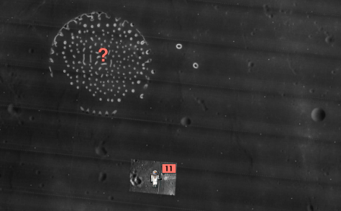**3. What is the** [**unknown site**](https://www.google.com/moon/#lat=1.293420&lon=24.677856&zoom=8&apollo=other/3) **(marked with a ?) to the north west of the Apollo 11 landing?**

**4. Read** [**this set of instructions**](http://www.hq.nasa.gov/alsj/a11/a11sur25.gif) **that were followed before exiting the Lunar Lander. What actions did the astronauts take to ensure they were protected while on the Moon’s surface?**

**5. This link contains part of the mission debrief that the astronauts participated in. What two problems did Aldrin and Armstrong have when trying to land the Eagle? How did the astronauts describe the landing?**

<https://goo.gl/i62k9a>

**6. What are the dark lines visible on the Lunar surface?**

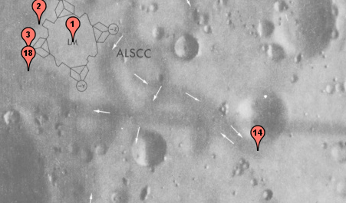

**7. Use the scale on the bottom right of this** [**Google Moon map**](https://www.google.com/moon/#lat=0.655703&lon=23.471843&zoom=19&apollo=other/3)**. How far did Armstrong walk from the Lunar Module to photograph the Little West Crater?**

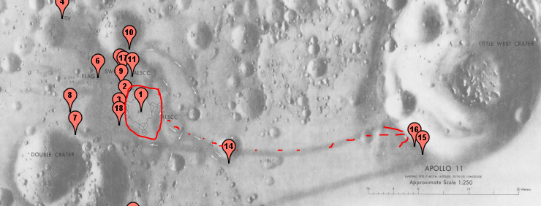

**8. Columbia splashed down near** [**Johnston Atoll**](https://www.google.com/maps/place/Johnston+Island/@16.7313889,-169.5519539,14z/data=!4m5!3m4!1s0x7b756673ae736635:0x23047b3cd6523f5!8m2!3d16.7313889!4d-169.5344444)**, a US Minor Outlying Island. Where is Johnston Atoll?**